RECOMP Sprint 1 Report – Group 5

Isaac Santos – 1181242

André Teixeira – 1190384

Wimy Carvalho – 1161297

Matija Zupanc - 1240290



Table of contents

Introduction 2

Address Schemes 3

Oporto 3

BR Warsaw 6

BR Munich 7

Device configuration 7

Oporto 8

VLAN Configuration 8

STP 8

HSRP 9

VLAN on switches 9

DHCP configuration 10

Warsaw and Munich Configuration 11

Warsaw 11

Munich 12

# Introduction

In this report it will be detailed how the network created for 3 sites of the hypothetical company *“RECOMP Corporation WAN”*, with each of those sites located in Oporto, Warsaw and Munich was setup. Each section of this report will be dedicated to each of these sites, and how their local networks were configured.

# Address Schemes

## Oporto

Parameters for our group:

* Porto IPV4 address: 10.27.68.0/22
* Warsaw IPV4 address: 192.168.154.0/23
* Munich IPV4 address: 172.21.72.0/23
* VTP Domain: RECOMP2425M1B05
* DHCP Domain: RECOMP2425M1B05.recomp.com

Here follows a table with all available networks in the Oporto location site. Four separate networks were setup on this site:

* Users, with 500 nodes
* Accounting, with 200 nodes
* HR, with 100 nodes
* Staff, with 50 nodes

|  |  |  |  |  |  |
| --- | --- | --- | --- | --- | --- |
| Network | Network address | Broadcast address | Mask | First valid node address | Last valid node address |
| VLAN 40 - USERS - 500 nodes | 10.27.68.0/23 | 10.27.69.255 | 255.255.254.0 | 10.27.68.1 | 10.27.69.254 |
| VLAN 20 - ACCOUNTING - 200 nodes | 10.27.70.0/24 | 10.27.70.255 | 255.255.255.0 | 10.27.70.1 | 10.27.70.254 |
| VLAN 30 - HR - 100 nodes | 10.27.71.0/25 | 10.27.71.127 | 255.255.255.128 | 10.27.71.1 | 10.27.71.126 |
| VLAN 10 - STAFF - 50 nodes | 10.27.71.128/26 | 10.27.71.191 | 255.255.255.192 | 10.27.71.129 | 10.27.71.190 |
| HQ Router - HQ-MLS1 | 10.27.71.192/30 | 10.27.71.195 | 255.255.255.252 | 10.27.71.193 | 10.27.71.194 |
| HQ Router - HQ-MLS2 | 10.27.71.196/30 | 10.27.71.199 | 255.255.255.252 | 10.27.71.197 | 10.27.71.194 |

Depicted below is a visual representation of the same network scheme.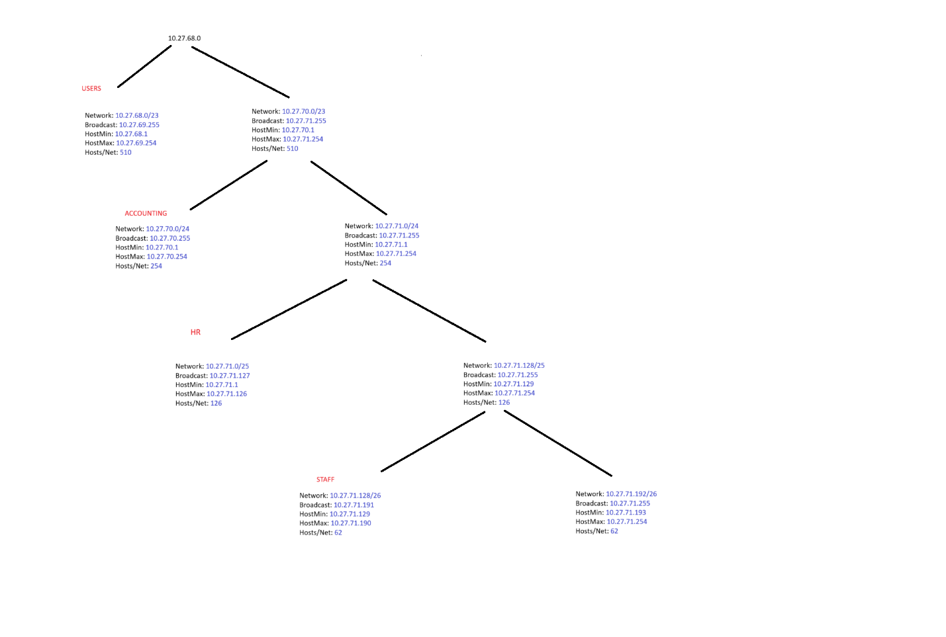

The following table represents the interface and assigned addresses for each router/switch in the Oporto network.

|  |  |  |  |  |
| --- | --- | --- | --- | --- |
| HQ(PORTO) - Router | Gig0/0/0 | Gig0/0 | Gig0/1 |  |
| 209.165.200.129 | 10.27.71.193 | 10.27.71.197 |  |
| HQ-MLS1 - Multilayer Switch | VLAN 10 | VLAN 20 | VLAN 30 | VLAN 40 |
| 10.27.71.129 | 10.27.70.1 | 10.27.71.1 | 10.27.68.1 |
| HQ-MLS2 - Multilayer Switch | VLAN 10 | VLAN 20 | VLAN 30 | VLAN 40 |
| 10.27.71.130 | 10.27.70.2 | 10.27.71.2 | 10.27.68.2 |

Redundancy between MLS1 and MLS2

The interconnection between the multilayer switches establishes a redundant path within the network. Should one of the switches fail, the other seamlessly takes over the traffic, ensuring high availability.

Cross-Connections

The "X" connecting the multilayer switches to the access switches represents redundancy at the access level. This means that the access switches have alternative pathways to communicate with the main switches (MLS1 or MLS2), enhancing network resilience and preventing the failure of a single switch from disrupting operations.

Multilayer Switch

As multilayer switches, MLS can perform routing functions (Layer 3) in addition to standard switching (Layer 2). This capability facilitates efficient routing between different VLANs, optimizing communication across the network.

Connections between Router and Switches(**Router - MLS1 - SW1** and **Router - MLS2 - SW2**), the connections between the router and the multilayer switches utilize Gigabit Ethernet (GigE) technology. This choice is critical, as Gigabit Ethernet offers superior bandwidth (1 Gbps) compared to Fast Ethernet (100 Mbps). Given that these multilayer switches manage a substantial volume of traffic and serve as the backbone of the network, a faster connection ensures optimal performance and reduced latency.

Therefore, whenever possible, we should prioritize the use of Gigabit Ethernet for primary connections to guarantee greater transmission capacity and efficient redundancy.

## BR Warsaw

The addressing scheme for BR1 networks in Warsaw is as follows:

|  |  |  |  |  |  |
| --- | --- | --- | --- | --- | --- |
| Network | Network address | Broadcast address | Mask | First valid node address | Last valid node address |
| USERS - 200 nodes - VLAN 40 | 192.168.154.0/24 | 192.168.154.255 | 255.255.255.0 | 192.168.154.1 | 192.168.154.254 |
| ACCOUNTING - 200 nodes - VLAN 20 | 192.168.155.0/24 | 192.168.155.255 | 255.255.255.0 | 192.168.155.1 | 192.168.155.254 |

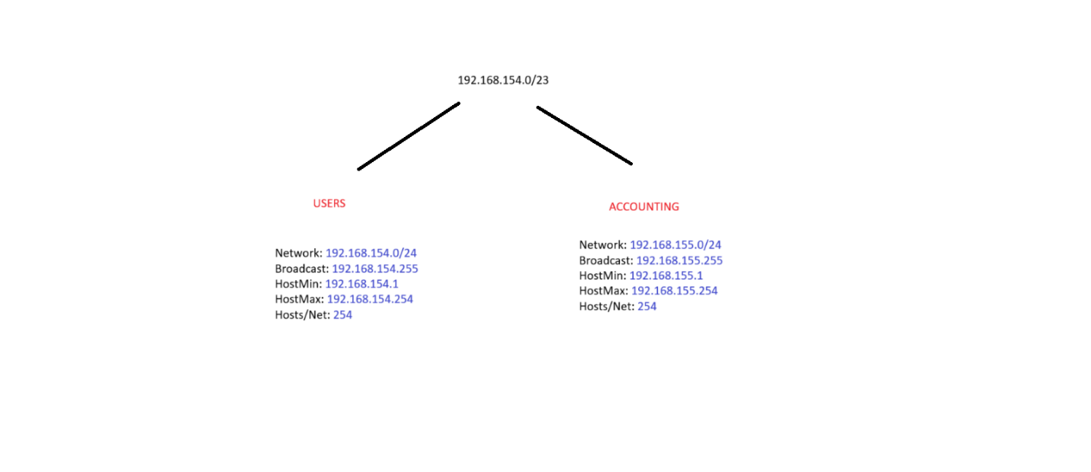

The following table represents the interfaces and assigned addresses for the router in the Warsaw network

|  |  |  |  |
| --- | --- | --- | --- |
| BR1 (Warsaw) - Router | Gig0/0/0 | f0/1-10 - VLAN 20 | f0/11-20 - VLAN 40 |
| 192.0.2.97 | 192.168.155.1 | 192.168.154.1 |

## BR Munich

The addressing scheme for BR2 networks in Munich is as follows:

|  |  |  |  |  |  |
| --- | --- | --- | --- | --- | --- |
| Network | Network address | Broadcast address | Mask | First valid node address | Last valid node address |
| USERS - 200 nodes - VLAN 40 | 172.21.72.0/24 | 172.21.72.255 | 255.255.255.0 | 172.21.72.1 | 172.21.72.254 |
| STAFF - 200 nodes - VLAN 10 | 172.21.73.0/24 | 172.21.73.255 | 255.255.255.0 | 172.21.73.1 | 172.21.73.254 |

The following table represents the interfaces and assigned addresses for the router in the Munich network

|  |  |  |  |
| --- | --- | --- | --- |
| BR2 (Munich) - Router | Gig0/0/0 | f0/1-10 - VLAN 10 | f0/11-20 - VLAN 40 |
| 193.136.60.147 | 172.21.73.1 | 172.21.72.1 |

# Device configuration

## Oporto

Starting off, the first configuration done at Oporto was joining two interfaces between the main Multi-layer switches, and configuring them as a trunk.

### VLAN Configuration

For multilayer switch 1 (MLS1), the FastEthernet ports 1-24 are configured as trunks using 802.1Q encapsulation, allowing all VLANs, with VLAN 50 set as the native VLAN. For both switches, VLAN 10 (STAFF), 20 (ACCOUNTING), 30 (HR), 40 (USERS), 50 (NATIVE), and 99 (BLACKHOLE) are created. Both switches share the same VTP domain "RECOMP2425M1B05" with the password "4232pmocer" and are configured in VTP server mode.

|  |  |
| --- | --- |
| **MLS1** | **MLS2** |
| interface range fa0/1 - 24  switchport trunk encapsulation dot1q  switchport mode trunk  switchport trunk allowed vlan all  switchport trunk native vlan 50  vlan 10  name STAFF  vlan 20  name ACCOUNTING  vlan 30  name HR  vlan 40  name USERS  vlan 50  name NATIVE  vlan 99  name BLACKHOLE  vtp domain RECOMP2425M1B05  vtp password 4232pmocer  vtp mode server | vlan 10  name STAFF  vlan 20  name ACCOUNTING  vlan 30  name HR  vlan 40  name USERS  vlan 50  name NATIVE  vlan 99  name BLACKHOLE  vtp domain RECOMP2425M1B05  vtp password 4232pmocer  vtp mode server |

### STP

At this point it is indicated that MLS1 must be defined as root bridge for VLANS 10 and 20, and this must be the secondary root bridge for VLANS 30 and 40, using rapid-STP. Furthermore, MLS2 must have the configuration opposite to MLS1, thus being the root bridge for VLANS 30 and 40, and secondary root bridge for VLANS 10 and 20.

We added the following commands:

|  |  |
| --- | --- |
| **MLS1** | **MLS2** |
| spanning-tree vlan 10 root primary  spanning-tree vlan 20 root primary  spanning-tree vlan 30 root secondary  spanning-tree vlan 40 root secondary | spanning-tree vlan 30 root primary  spanning-tree vlan 40 root primary  spanning-tree vlan 10 root secondary  spanning-tree vlan 20 root secondary |

### HSRP

In the next step, we configured the HSRP protocol to ensure both multilayer switches (MLSs) work well together. For each network, we designated one of the two switches as the priority switch, with each switch serving as the priority for two of the networks. This configuration ensures that both switches share the load and provide redundancy, maintaining network availability in case one switch fails.

|  |  |
| --- | --- |
| **MLS1** | **MLS2** |
| interface vlan10  ip address 10.27.71.129 255.255.255.192  standby 10 ip 10.27.71.190  standby 10 priority 110  standby 10 preempt    interface vlan20  ip address 10.27.70.1 255.255.255.0  standby 20 ip 10.27.70.254  standby 20 priority 110  standby 20 preempt    interface vlan30  ip address 10.27.71.1 255.255.255.128  standby 30 ip 10.27.71.126  standby 30 priority 90  standby 30 preempt    interface vlan40  ip address 10.27.68.1 255.255.254.0  standby 40 ip 10.27.69.254  standby 40 priority 90  standby 40 preempt | interface vlan30  ip address 10.27.71.2 255.255.255.128  standby 30 ip 10.27.71.125  standby 30 priority 110  standby 30 preempt    interface vlan40  ip address 10.27.68.2 255.255.254.0  standby 40 ip 10.27.69.253  standby 40 priority 110  standby 40 preempt    interface vlan10  ip address 10.27.71.130 255.255.255.192  standby 10 ip 10.27.71.179  standby 10 priority 90  standby 10 preempt    interface vlan20  ip address 10.27.70.2 255.255.255.0  standby 20 ip 10.27.70.253  standby 20 priority 90  standby 20 preempt |

### VLAN on switches

Moving on from multilayer switches, the Layer 2 switches were configured to allow the appropriate VLANs to pass through them. This configuration increases stability and removes unnecessary traffic from the network. Additionally, the VTP domain was created to enhance security.

|  |  |
| --- | --- |
| **SW1** | **SW2** |
| vtp domain RECOMP2425M1B05  vtp password 4232pmocer  vtp mode client    interface range FastEthernet 0/1-4  switchport mode trunk  no shutdown    interface range FastEthernet 0/5-8  switchport mode access  switchport access vlan 10  no shutdown    interface range FastEthernet 0/9-12  switchport mode access  switchport access vlan 20    interface range FastEthernet 0/13-16  switchport mode access  switchport access vlan 30    interface range FastEthernet 0/17-20  switchport mode access  switchport access vlan 40    interface range FastEthernet 0/21-24  switchport mode access  switchport access vlan 99 | vtp domain RECOMP2425M1B05  vtp password 4232pmocer  vtp mode client    interface range FastEthernet 0/5-8  switchport mode access  switchport access vlan 10    interface range FastEthernet 0/9-12  switchport mode access  switchport access vlan 20    interface range FastEthernet 0/13-16  switchport mode access  switchport access vlan 30    interface range FastEthernet 0/17-20  switchport mode access  switchport access vlan 40    interface range FastEthernet 0/21-24  switchport mode access  switchport access vlan 99 |

To check the propagation of VLANS across the remaining switches, on each switch, we used the command below and the following result was obtained:

### DHCP configuration

To ensure each user automatically receives an IP address, we configured the DHCP protocol. By adding VLAN pools and excluding specific addresses, we improve network stability and security.

|  |  |
| --- | --- |
| **MLS1** | **MLS2** |
| ip dhcp excluded-address 10.27.71.129 10.27.71.130  ip dhcp excluded-address 10.27.71.178 10.27.71.179  ip dhcp pool VLAN10-STAFF  domain-name RECOMP2425M1B05  network 10.27.71.128 255.255.255.192  default-router 10.27.71.193  dns-server 8.8.8.8    ip dhcp excluded-address 10.27.70.1 10.27.70.2  ip dhcp excluded-address 10.27.70.253 10.27.70.254  ip dhcp pool VLAN20-ACCOUNTING  domain-name RECOMP2425M1B05  network 10.27.70.0 255.255.255.0  default-router 10.27.70.1  dns-server 8.8.8.8 | ip dhcp excluded-address 10.27.71.1 10.27.71.2  ip dhcp excluded-address 10.27.71.125 10.27.71.126  ip dhcp pool VLAN30-HR  domain-name RECOMP2425M1B05  network 10.27.71.0 255.255.255.128  default-router 10.27.71.2  dns-server 8.8.8.8    ip dhcp excluded-address 10.27.68.1 10.27.69.254  ip dhcp excluded-address 10.27.68.2 10.27.69.253  ip dhcp pool VLAN40-USERS  domain-name RECOMP2425M1B05  network 10.27.68.0 255.255.254.0  default-router 10.27.68.2  dns-server 8.8.8.8 |

## Warsaw and Munich Configuration

After configuring the HQ network, we focused on ensuring connectivity with the two other branches. Similar to the HQ network, we created VLAN pools and implemented the DHCP protocol to achieve automatic IP address assignment. Additionally, we configured the switches to allow only specific VLANs on their interfaces, which enhances the reliability and structure of our branch networks.

### Warsaw

|  |  |
| --- | --- |
| **BR** | **SW1** |
| hostname Warsaw  ip dhcp pool VLAN20-ACCOUNTING  network 192.168.155.0 255.255.255.0  default-router 192.168.155.254  dns-server 8.8.8.8  ip dhcp pool VLAN40-USERS  network 192.168.154.0 255.255.255.0  default-router 192.168.154.254  dns-server 8.8.8.8  interface GigabitEthernet0/0.20  encapsulation dot1Q 20  ip address 192.168.155.254 255.255.255.0  interface GigabitEthernet0/0.40  encapsulation dot1Q 40  ip address 192.168.154.254 255.255.255.0  ip dhcp excluded-address 192.168.154.254  ip dhcp excluded-address 192.168.155.254 | hostname SW1  interface GigabitEthernet0/1  switchport access vlan 50  switchport trunk native vlan 50  switchport mode trunk  interface FastEthernet0/1-10  switchport access vlan 20  switchport mode access  interface FastEthernet0/11-20  switchport access vlan 40  switchport mode access  interface FastEthernet0/21-24  switchport access vlan 99  switchport mode access  shutdown |

### Munich

This branch differs from the previous one in the manually configured router IP address. Everything else remains similar.

|  |  |
| --- | --- |
| **BR** | **SW1** |
| hostname Munich  interface GigabitEthernet0/0/0  ip address 193.136.60.147 255.255.255.248  ip classless  ip route 0.0.0.0 0.0.0.0 193.136.60.150  ip dhcp pool VLAN10-STAFF  network 172.21.73.0 255.255.255.0  default-router 172.21.73.254  dns-server 8.8.8.8  ip dhcp pool VLAN40-USERS  network 172.21.72.0 255.255.255.0  default-router 172.21.72.254  dns-server 8.8.8.8  interface GigabitEthernet0/0.10  encapsulation dot1Q 10  ip address 172.21.73.254 255.255.255.0  interface GigabitEthernet0/0.40  encapsulation dot1Q 40  ip address 172.21.72.254 255.255.255.0  ip dhcp excluded-address 172.21.73.254  ip dhcp excluded-address 172.21.72.254 | hostname SW1  interface GigabitEthernet0/1  switchport access vlan 50  switchport trunk native vlan 50  switchport mode trunk  interface FastEthernet0/1-10  switchport access vlan 10  switchport mode access  interface FastEthernet0/11-20  switchport access vlan 40  switchport mode access  interface FastEthernet0/21-24  switchport access vlan 99  switchport mode access  shutdown |